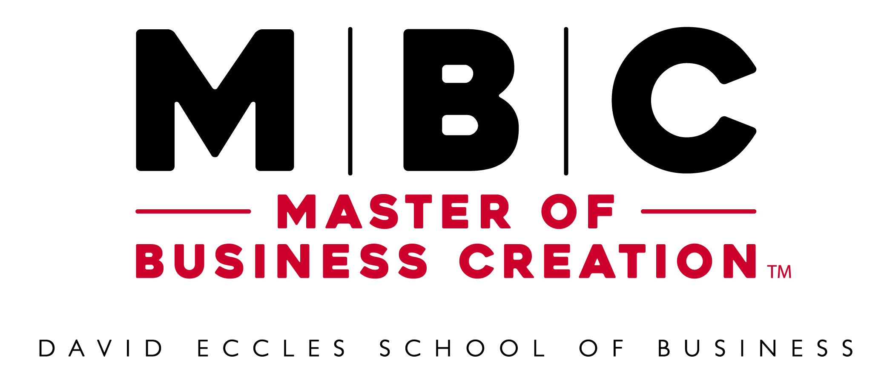
Master of Business Creation Factsheet
Updated: 5-14-19

About the Master of Business Creation
Short Version
A specialized nine-month graduate degree program for founders committed to launching their startup company aided by an innovative, application-focused curriculum and access to mentoring, funding and scholarships.
Long Version
The Master of Business Creation (MBC) is a nine-month, professional-degree program for serious entrepreneurs committed to launching their startup company aided by an innovative, application-focused curriculum and access to mentoring, funding and scholarships. The program is offered by the David Eccles School of Business and Lassonde Entrepreneur Institute at the University of Utah, which have an entrepreneur program ranked among the top 10 in the nation. The MBC degree has courses, workshops and labs specifically designed for aspiring entrepreneurs to gain the knowledge and skills needed to create and scale their business. Founders work full-time on their companies, take entrepreneurially focused classes, engage in practicum labs and receive personalized support. Faculty and mentors in the program are leading scholars and experienced entrepreneurs who can provide detailed insight into all stages of the entrepreneurial process. Learn more at Eccles.Utah.edu/MBC.
Taglines
Entrepreneur is a Verb. Start Doing.
- Entrepreneur Your Startup. Get a Master of Business Creation.
- Entrepreneur Your Dreams. Get a Master of Business Creation.
- Entrepreneur to a Master of Business Creation
- Entrepreneur Your Master’s Degree
- Entrepreneur a Master’s at the Eccles School
- Entrepreneur a Master’s Degree in 9 Months

Benefits & Qualities
Master the Art of Creating and Scaling a New Business
The skill and knowledge to create and scale a new business are fundamentally different from managing an existing business, but they can be learned and mastered. MBC founders will develop this expertise by working on their startup while learning from experts and each other.
Full-Time Focus on Your Startup
Founders in the MBC program are focused on their startup. Their time on campus and progress in the program revolve around their company. They spend their time cultivating their ideas while accessing classes, people and resources that will help them develop their concept and make it successful.
Intensive 9-Month Experience
The MBC is exclusively for founders committed to launching an enterprise within nine months of starting the program. It requires complete engagement on the part of the founders in the program. This is not a program where founders will take courses a couple of days a week and keep a part-time job. It is a program that is six days a week, 14 hours a day.
Top 10 Program
The David Eccles School of Business is ranked among the top 10 schools in the country for entrepreneurship education by the Princeton Review, U.S. News and Bloomberg. These rankings recognize the variety, depth and quality of opportunities for founders who want to learn how to launch companies.
Business Accelerator Meets Business Degree
The MBC program combines the best parts of a business accelerator and a graduate business-degree program to help entrepreneurs advance their startup companies. Founders receive personalized, in-depth support and resources while also taking classes on related topics from renowned faculty at a top-ranked business school.
Keep Your Equity
Unlike an accelerator, the MBC program does not take any equity in participating startup companies. The MBC program works to add value to startup companies, not extract it, and is solely focused on accelerating your success.
Generous Scholarships
Full and partial scholarships are available to support founders participating in the MBC program. The scholarships are designed to allow founders to use their resources on their startup idea instead of financing their education. Scholarship availability will be determined during the application process.
Abundant Resources
Founders in the MBC program gain access to unique resources to support their startups. Resources include office space, exclusive access to experts and funding, and more. The resources will reduce the risk of starting a company and give founders a jumpstart toward achieving a profitable enterprise.
High-Quality Entrepreneurship Education
Faculty and mentors in the MBC program come from a wide range of backgrounds and have deep knowledge and experience in all areas related to entrepreneurship. Courses in the program are designed to help working entrepreneurs who need help on real startup problems now. Founders have the option to customize their educational experience to meet their goals.
Create Your Future
The founders who enroll in the MBC program create their jobs, careers and futures. Founders who enter the program do not want to work for someone else and are willing to do the work necessary to launch an enterprise that will define them for many years to come.
Learn by Doing
Starting a company is a great way to learn about business. Founders in the MBC program get a rich experience managing everything from finance and human resources to product development and marketing. The lessons they learn will be vital for their future as an entrepreneur and business leader.
Cohort Structure
The cohort structure of the program, along with the intensive coaching in the practicums, supports group-based learning. Founders in the program not only learn from their experience starting an enterprise, they also observe their colleague's startup efforts in detail and have an opportunity to learn from a variety of challenges and solutions across their entire cohort.
Course Requirements
The MBC is comprised of required courses, integrated practicum courses and program workshops featuring special topics sessions over two semesters (33 total credits minimum). Founders may choose to add electives to their program of study with advisor and graduate school approval in the case of an overload. All courses are taken in lock-step with a cohort of founders progressing through the two-semester, full-time program together.
Required Classes (Subject to Change)
- MBC Program Workshops
- Developing Your Business Model
- Testing Your Business Model
- Negotiation for Entrepreneurs
- Legal Issues for Entrepreneurs
- Business Creation
- Practicums
- Business Launch
- Entrepreneurial Management Accounting
- Entrepreneurial Competitive Strategy
- Leading and Scaling the Entrepreneurial Enterprise
Electives
Many electives are available at the David Eccles School of Business in topics including accounting, entrepreneurship, finance, management, marketing, operations, information systems and strategy.
Learning Objectives
- Mastering complex analysis and problem-solving
- Executing fast-cycle-time learning
- Negotiating solutions in multiple-constituency, multiple-issue environments
- Navigating ambiguity
- Working with people
- Emotional intelligence in the face of setbacks and failures
- Leading innovation
How to Apply
The admission requirements for the MBC degree are similar to those of other programs within the David Eccles School of Business, but the MBC has a more interview-intensive admissions process than is typical for larger programs. Start the application process at Eccles.Utah.edu/MBC.
Application Requirements (Subject to Change)
- Step 1: General University of Utah Graduate School application
  - All candidates must first complete the general University of Utah graduate school application. Requirements at this stage include:
    - Transcripts/GPA
      - Applicants must provide official transcripts for all colleges and universities they attended regardless of length of attendance. A minimum cumulative 3.0 undergraduate GPA is required for admission. We will accept a 3.0 GPA from the last 60 credit hours taken in cases where the overall GPA is below 3.0.
      - GRE/GMAT test score is suggested for founders whose prior academic record does not meet the minimum GPA requirement. No minimum GRE or GMAT score is required for application. All application materials are evaluated to determine the strength of the application.
    - English language proficiency.
      - International applicants must receive a minimum score of 90 on the TOEFL iBT exam or 6.5 on the IELTS exam.
- Step 2: MBC admissions review materials
  - Select candidates will be asked to asked to submit additional materials, including:
    - Description of the enterprise you have launched or are proposing to launch
    - One-page, statement-of-purpose essay, describing the your intent and goals for the program
    - Slide deck, video and/or other materials describing the enterprise
    - A set of questions designed to assess the state of your enterprise
    - Contact information for two references, who will be contacted and interviewed
Program Cost: 2019-20
The estimated tuition cost for the MBC is $44,000 for the 2019-20 academic year. Scholarships are available for the entire amount from the Lassonde Entrepreneur Institute and the David Eccles School of Business for up to three team members per startup. During the 2019-20 academic year, the planned MBC cohort will be 15-20 individuals and will grow to 40-50 over several years.
Entrepreneur is a Verb. Start Doing.
Entrepreneur is a verb at the David Eccles School of Business and Lassonde Entrepreneur Institute at the University of Utah. Students learn and grow by doing. Students receive training, mentorship and resources with the expectation to get involved, launch something, join a team and make a difference. Entrepreneur your education. Entrepreneur your future. Entrepreneur your dreams. Entrepreneur at the Eccles School.

