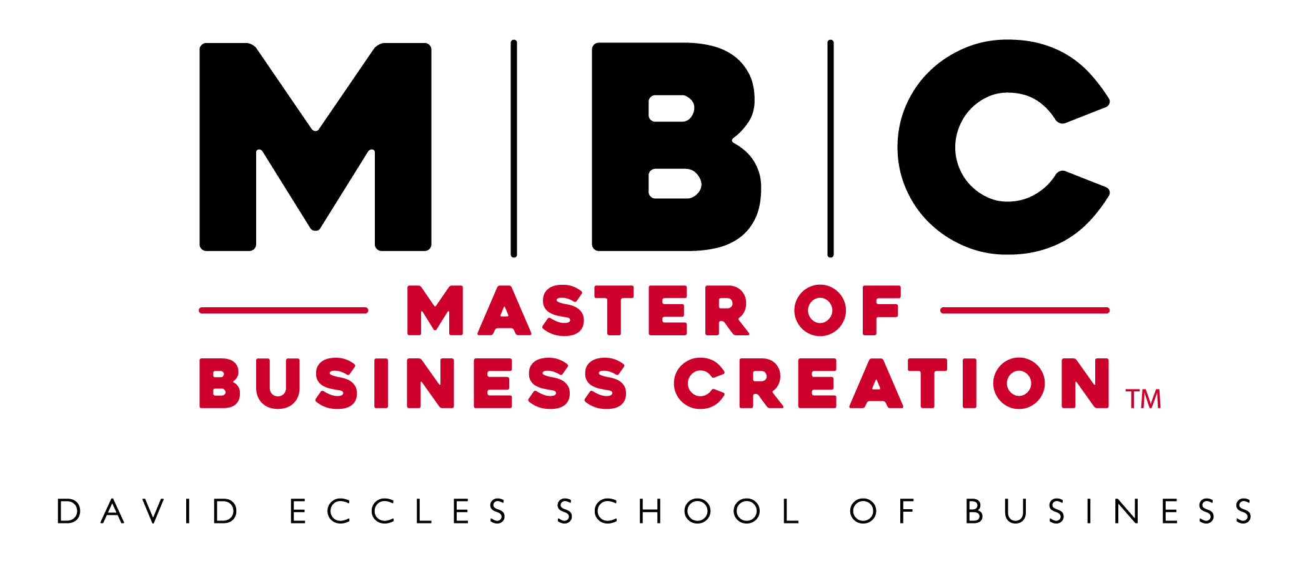
Master of Business Creation Factsheet
Updated: 3-3-23

About the Master of Business Creation
Short Version
A specialized professional-degree program for founders interested in an intensive immersion into company acceleration for their startups aided by mentoring, grants, and scholarships. Enroll full-time in-person or part-time online.
Long Version
The Master of Business Creation (MBC) is a professional-degree program for serious entrepreneurs committed to growing their startup company. The program features innovative, application-focused curriculum and access to mentoring, grants, and scholarships. The program is offered at the University of Utah’s David Eccles School of Business by the Department of Entrepreneurship & Strategy in partnership with the Lassonde Entrepreneur Institute. Together, they provide an entrepreneur program ranked among the top 10 in the nation. The MBC degree has courses, workshops, and labs specifically designed for aspiring entrepreneurs building and scaling their business. The program is available in two formats – an in-person, full-time, 9-month option or an online, part-time, 14-month option. In both options, founders work to grow their companies, take entrepreneurially focused classes, engage in practicum labs, and receive personalized support. Faculty and mentors in the program are leading scholars and experienced entrepreneurs who can provide detailed insight into all stages of the entrepreneurial process. Learn more at Eccles.Utah.edu/MBC.
Taglines
Entrepreneur is a Verb. Start Doing.
- Entrepreneur Your Startup. Get a Master of Business Creation.
- Entrepreneur Your Dreams. Get a Master of Business Creation.
- Entrepreneur to a Master of Business Creation
- Entrepreneur Your Master’s Degree
- Entrepreneur a Master’s at the Eccles School
- Entrepreneur a Master’s Degree In-Person or Online

Benefits & Qualities
Top 10 Ranked
The David Eccles School of Business is ranked among the top 10 schools for entrepreneurship by the US News & World Report. Its entrepreneurship programs are provided in partnership between the Department of Entrepreneurship & Strategy and the Lassonde Entrepreneur Institute.
Participate Full-Time In-Person or Part-time Online
Founders in the Master of Business Creation program can choose from two formats. Participate in the full-time format to complete the program in-person at the University of Utah over 9 months. Or participate online part-time from anywhere in 14 months.
Master the Art of Building and Scaling a New Business
The skill and knowledge to build and scale a new business are fundamentally different from managing an existing business, but they can be learned and mastered. MBC founders will develop this expertise by working on their startup while learning from experts and each other.
Focused on Your Startup
Founders in the MBC program are focused on their startup. Their time and progress in the program revolve around their company. They spend their time cultivating their ideas while accessing classes, people, and resources that will help them develop their concept and make it successful.
Intensive Experience
The MBC is exclusively for founders committed to achieving operating independence by the time they complete the program. It requires commitment on the part of the founders in the program.
Business Accelerator Meets Business Degree
The MBC program combines the best parts of a business accelerator and a graduate business-degree program to help entrepreneurs advance their startup companies. Founders receive personalized, in-depth support, and resources while also taking classes on related topics from renowned faculty at a top-ranked business school.
Keep Your Equity
Unlike an accelerator, the MBC program does not take any equity in participating startup companies. The MBC program works to add value to startup companies, not extract it, and is solely focused on accelerating your success.
Generous Scholarships
Full and partial scholarships are available to support founders participating in the MBC program. The scholarships are designed to allow founders to use their resources on their startup idea instead of financing their education. Scholarship availability will be determined during the application process.
Abundant Resources
Founders in the MBC program gain access to unique resources to support their startups. Resources available include working space, exclusive access to experts and funding, and more. The resources reduce the risk of starting a company and give founders a jumpstart toward achieving a profitable enterprise.
High-Quality Entrepreneurship Education
Faculty and mentors in the MBC program come from a wide range of backgrounds and have deep knowledge and experience in all areas related to entrepreneurship. Courses in the program are designed to help working entrepreneurs who need help on real startup problems now. Founders can immediately apply what they learn in class to their startup.
Learn by Doing
Starting a company is a great way to learn about business. Founders in the MBC program get a rich experience managing everything from finance and human resources to product development and marketing. The lessons are vital for entrepreneurs and business leaders.
Cohort Structure
The cohort structure of the program, along with the intensive coaching in the practicums, supports group-based learning. Founders in the program not only learn from their experience starting an enterprise, they also observe their colleagues’ startup efforts in detail and have an opportunity to learn from a variety of challenges and solutions across their entire cohort.
Full-Time vs. Online Program
The MBC Full-Time and Online programs provide many of the same benefits but are provided in different ways over different periods of time. Here are some of the key comparisons:

MBC Full-Time
- In-person
- 9 months
- Daytime
- Fixed class times
- Scholarships
- Grants
- Personal mentorship
- Peer support
- Applied coursework
- & More
MBC Online
- Virtual
- 14 months
- Anytime
- Flexible class times
- Scholarships
- Grants
- Personal mentorship
- Peer support
- Applied coursework
- & More

Course Requirements
The MBC is comprised of required courses, integrated practicum courses, and program workshops featuring special topics sessions (30 total credits minimum). Founders may choose to add electives to their program of study with approval from their advisor and the graduate school in the case of an overload. All courses are taken with a cohort of founders progressing through the program together.
Required Classes (Subject to Change)
- Workshops
- Business Models
- Qualifying and Testing Business Models
- Competitive Dynamics
- Business Creation
- Practicums
- Business Launch
- Legal Issues, Contracting, and Negotiation for Entrepreneurs
- Leadership and HR
Learning Objectives
- Mastering complex analysis and problem-solving
- Executing fast-cycle-time learning
- Negotiating solutions in multiple-constituency, multiple-issue environments
- Navigating ambiguity
- Working with people
- Emotional intelligence in the face of setbacks and failures
- Leading innovation
How to Apply
The admission requirements for the MBC degree are similar to those of other programs at the David Eccles School of Business, but the MBC has a more interview-intensive admissions process than is typical for larger programs. A viable startup is required to enroll in the MBC program, and classroom learning will be immediately applied to the founder’s startup. Start the application process at Eccles.Utah.edu/MBC.
Application Requirements (Subject to Change)
- Step 1: General University of Utah Graduate School application
  - All candidates must first complete the general University of Utah graduate school application. Requirements at this stage include:
    - Transcripts/GPA
      - Applicants must provide official transcripts for all colleges and universities they attended regardless of length of attendance. A minimum cumulative 3.0 undergraduate GPA is required for admission. We will accept a 3.0 GPA from the last 60 credit hours taken in cases where the overall GPA is below 3.0.
    - GRE/GMAT test scores
      - Standardized test scores are not required for applicants with a GPA of 3.0 or higher.
- Step 2: MBC admissions review materials
  - Select candidates will be asked to submit additional materials, including:
    - Description of the enterprise you have launched or are proposing to launch
    - One-page, statement-of-purpose essay, describing your intent and goals for the program
    - Slide deck, video, and/or other materials describing the enterprise
    - A set of questions designed to assess the state of your enterprise
    - Contact information for two references, who will be contacted and interviewed
    - Resume that includes your education and work history
Tuition Costs & Scholarships
Scholarships are available from the Lassonde Entrepreneur Institute and the David Eccles School of Business for up to three co-founders per startup. Find tuition details on the University of Utah’s Financial and Business Resources website here: eccles.link/mbc-tuition.
Entrepreneur is a Verb. Start Doing.
Entrepreneur is a verb at the David Eccles School of Business and Lassonde Entrepreneur Institute at the University of Utah. Students learn and grow by doing. Students receive training, mentorship, and resources with the expectation to get involved, launch something, join a team, and make a difference. Entrepreneur your education. Entrepreneur your future. Entrepreneur your dreams. Entrepreneur at the Eccles School.

